**Camouflage Images Analysis Project**

This is a project assigned to me by Philip for analysis of the camouflage images and the solution for this can be used to analyse the environment of the South African boarders at different seasons.

**Requirements**

* From a given Image analyse the level of dominance of each colour in an image
* Group the images either in a database or in a file using the GIS information if available or date and time.
* Delete over and under exposed images- blurred images
* Delete images that are mostly dominant by blue.

**Current state of the project**

|  |  |
| --- | --- |
| **Task** | **Current state** |
| * From a given Image analyse the level of dominance of each colour in an image | **Done** |
| * Group the images either in a database or in a file using the GIS information if available or date and time. | **Done** |
| * Delete over and under exposed images- blurred images | **Not done yet** |
| * Delete images that are mostly dominant by blue. | **In process** |

**Completed Tasks**

* From a given Image analyse the level of dominance of each colour in an image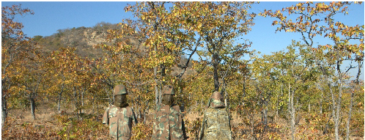



* Group the images either in a database or in a file using the GIS information if available or date and time.
* Read the EXIF data



* Create a folder using the date from the EXIF data and move the image to the right

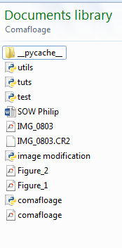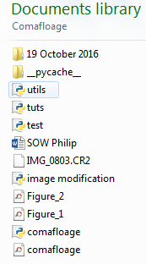

**Final Idea**

